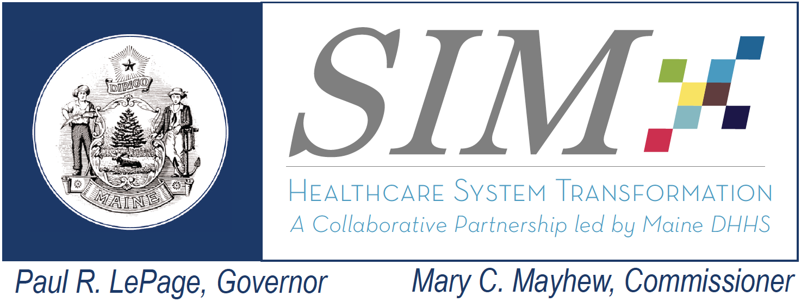 |  | SIM Steering Committee Meeting  July 27, 2016 9:00 AM – 12 PM  Maine General Medical Center- Conference Room 2  Conference Call #: 1-571-317-3131  Conference Code: 325-368-269  Webinar Link: https://global.gotomeeting.com/join/325368269
Topic | Lead | Objective and Planned Highlights of Discussion | Estimated Time
1- Welcome – Minutes Review and Acceptance | Stefanie Nadeau | Approve Steering Committee minutes from previous Steering Committee meeting | 10 minutes  9:00 – 9:10
2- MaineCare Data Focused Learning Collaborative (DFLC) Overview | Amy Dix | Objective: Provide overview on DFLC structure, plans and obtain input from Steering Committee | 30 minutes  9:10-9:40
3-Maine NDPP SIM risk mitigation update | Deb Wigand and Nate Morse | Objective: Update on the NDDP risk and advice from the Steering Committee | 15 Minutes  9:40-9:55
4- Subcommittee Updates | Frank Johnson, Lisa Nolan, Lisa Tuttle | Objective: Provide feedback on SIM subcommittee work and next steps | 25 minutes  9:55-10:20
5 - Public Comment |  |  | To begin no later than 10:20
Break 10:20- 10:30
6- SIM Self Evaluation- Focus Group | Curt Mildner | Focus Group of SIM Governance as part of SIM self evaluation | 10:30-12:00

